JS2 Creative Art notes
EUCHARISTIC COLLEGE
Instructions: copy the notes from week one (topic 1) to week four (4 topics). You will copy the remaining notes in class.
Students should come to school with their drawing materials (Drawing book or sketch pad, pencils or charcoal pencils, eraser etc.)

Scheme of work
1st week: Elements of Art and design
2nd week: Principles of Art
3rd week: Perspective Drawing
4th week: Drawing and shading
5th week : Practical on Still life drawing
6th week: Pattern and Design
1st week: (Topic 1) ELEMENTS OF ART AND DESIGN
The elements of art are the visual or the basic components used by artists to create a work of art.
Elements of art can be defined as a planned and orderly arrangement of things within a given space that create an interesting design.
Elements of art are the things created and arranged together within a given space to create beautiful design.
Every artwork is composed of materials or things by which it is made. This elements must be organized within an area to create an interesting design. Therefore the ability to arrange or make effective use of those elements following the principles of art brings success to a work of art.
Elements of Art and design are:
- Line
- Colour
- Shape and form
- Texture
- Space
- Tone (value)
Line: A mark with length and direction. It can be straight, curved, thick, thin, bold, slim, long or short, in horizontal, vertical or slanting etc. In design, it defines the shape we use in design.
Color: The hue, value, and intensity of an object. Color can express moods and emotions. Is a medium used for creative work of art. Is a great source of beauty in design, it gives a work of art harmony.
Shape: shape means the structure or area of a thing as define by it edges. A flat, enclosed area that has two dimensions—length and width. Shapes can be geometric (like squares and circles) or organic (free-form or natural shapes).
Form: A three-dimensional object having volume and thickness. Form reveals the three dimensional structure or solidity of the shape through shading or the use of tones. It can be viewed from many angles. Forms can be geometric (like cubes and spheres) or organic.
Texture: The surface quality or "feel" of an object, its smoothness, roughness, softness, etc. Texture can be actual (felt) or implied (suggested by the way the artist renders areas of the picture).
Space: The area between, around, above, below, or within objects. Space can be positive (filled with something) or negative (empty areas).
Value (Tone): The lightness or darkness of a color. It helps to create depth and dimension in an artwork.
EUCHARISTIC COLLEGE
2ND WEEK (Topic 2) PRINCIPLES OF ART
The principles of art are the rules or guidelines that artists follow to create a successful composition.
Principles of art are the rules and guideline that artist use to organize the elements of art in an artwork.
Principles of art are factors that influences good design or a guide to create beautiful design.
A work of art is therefore successful, if the elements are well organized or arranged following the principles of art.
Here are the principles of art:
- Balance
- Perspective
- Proportion
- Variety
- Prepetition
- contrast
- Pattern
- Harmony
- movement
Balance: The distribution of visual weight or elements in a work of art. It can be symmetrical (evenly balanced) or asymmetrical (uneven but still balanced).
Perspective: deals with the size and distance, it creates changes in object appearance smaller and shorter as they get farther away.
Proportion: this refers to the size relation of one part of an object to another part of the object or of one part of the object to the whole object.
Variety: The use of different elements and principles to create interest and avoid monotony in the artwork.
Repetition (Emphasis): The part of the artwork that catches the viewer’s attention. It is often created by contrast.
Contrast: The difference between elements in an artwork. This can be differences in color, texture, value, or other elements to create interest and emphasis.
Movement: The path the viewer’s eye takes through the artwork, often to focal areas. Movement can be directed along lines, edges, shapes, and colors.
Pattern: The repetition of a design, which can create rhythm and unity in an artwork.
Harmony (Rhythm): A sense of movement created by the repetition of visual elements. It can be regular or irregular.
Unity: The feeling of harmony between all parts of the artwork, creating a sense of completeness.

3RD WEEK (Topic 3) Perspective drawing
Perspective drawing is a technique used to represent three-dimensional objects on a two-dimensional surface (like paper) in a way that looks natural and realistic.
Perspective is the art of representing the true appearance of an object on a two dimensional surface.
Perspective drawing is a method of creating the illusion of depth and space on a flat surface. It uses a set of guidelines and techniques to simulate how objects appear smaller as they get further away from the viewer, converging towards a vanishing point.
Some art terms in perspective drawing
Explanation:
Picture plane: the surface available for the drawing or painting as the case may be. The paper or canvas or any other plane is often represent with a rectangle or a square.
Horizon Line or Eye Level: This is the level at which the sky meets the ground. It represents the viewer's eye level. It is an imaginary line drawn along the picture plane at the point where objects are no longer visible but rather the sky now seems to meet with the ground in the distance.
Above and below eye level: in linear perspective any part of an object that falls below the horizon line is said to be below the eye level or worm’s eye view. In the same way any part of such object in a picture that rest above the line is above the eye level or bird’s eye view
Vanishing Point: This is a point on the horizon line where parallel lines appear to converge. It’s the spot where objects seem to disappear as they get farther away from the viewer.
Background: Areas that are far away from the artist or the observer. The distance which is an opposite of foreground.
Foreground: the part of the picture plane that is closer to the artist in landscape.
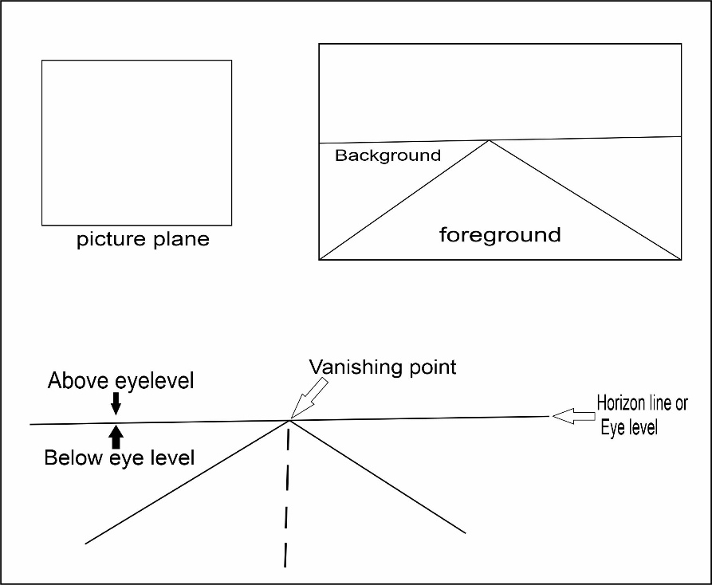

Orthogonal Lines: These are lines that lead to the vanishing point. They help guide the perspective and create the illusion of depth.
Types of perspective
- linear perspective
- Aerial perspective
Linear perspective: is the types of perspective that involves straight line, linear derives it forms from LINES. The following are the two types of linear perspective.
- Angular perspective
- Parallel perspective.
Aerial perspective: it shows the effect of distance on colour and tones on objects as they recede from the observer.
Types of Linear ( Angular ) Perspective:
One-Point Perspective: Uses a single vanishing point on the horizon line. It’s often used to draw roads, railways, or buildings viewed directly from the front.
Example: Looking straight down a railroad track, where the tracks appear to converge at a single point on the horizon.
Two-Point Perspective: Uses two vanishing points on the horizon line. This method is useful for drawing objects at an angle, such as the corner of a building.
Example: Looking at the corner of a building where two sides recede towards two different points on the horizon.
Three-Point Perspective: Uses three vanishing points, two on the horizon line and one either above or below the horizon line. This is used for drawing objects from a high or low point of view.
Example: Looking up at a skyscraper from ground level or looking down from a tall building.
Reasons for perspective drawing.
Four important reasons why perspective drawing is crucial for art students:
Realistic Representation: Perspective drawing allows us to create realistic and proportionate representations of objects and scenes, enhancing the lifelike quality of their artwork.
Understanding Spatial Relationships: It helps us grasp how objects relate to each other in space, including their size, distance, and position, fostering a better understanding of spatial dynamics.
Skill Development: Mastering perspective drawing hones technical drawing skills, such as precision and attention to detail, which are essential for various artistic disciplines.
Creative Expression: Understanding perspective enables artist to manipulate and play with space creatively, allowing for more dynamic and imaginative compositions in their artwork.
4TH WEEK (TOPIC 4) DRAWING AND SHADING (Drawing exercise)
EUCHARISTIC COLLEGE
Drawing is the art of using line to express an idea on a two dimensional surface like paper, canvas and wall etc.
Drawing is the art of creating images with lines while shading is the process of creating areas of light and dark (shade in a drawn object).
Types of shading
- Pointillism
- Cross-hatching
- Hatching
- Blurring/smoothing or woolly
- Scribble
5th week Still-life Drawing Exercise
6TH Week (TOPIC 6:) PATTERN AND DESIGN

