GARMENT MAKING NOTE (SS 1)
SECOND TERM 2024/2025 SESSION
SCHEME OF WORK
Lesson One: Sewing tools and equipment
Lesson Two: Care of Sewing tools and equipment
Lesson Three: Sewing Machines
Lesson Four: Care of Sewing Machine
Lesson Five: Machine Faults
Lesson Six: Basic Stitches
Lesson Seven: Seams
Lesson Eight: Seams and Finishes
Lesson Nine: Arrangement of Fullness

LESSON ONE
SEWING TOOLS AND EQUIPMENT
Sewing tools and equipment are used to construct garments and complete sewing tasks. They can be classified into five categories based on their use: Measuring, cutting, Marking, Stitching and Pressing
Sewing tools are the various instruments used for sewing by hand or machine. They include items such as scissors, needles, pins, thimbles and thread. Each tool has a specific purpose in the sewing process, and it is important to know what each one is called and how to use it correctly.
TYPES OF EQUIPMENT AND TOOLS
- Storage
- Cleaning
- Measuring
- Cutting out
- Sewing or joining
- Fitting
- Pressing
- Marking
- Other small tools

- STORAGE EQUIPMENT
Equipment | Uses and care
Wardrobes | For keeping clothes
Cupboards | For keeping clothes
Lockers | For keeping other clothing items.  Clean occasionally and put insecticides to keep away cockroaches
Hangers | For hanging cloths choose different sizes of plastic, wooden and metal hanger.
Bags | To keep needle work and other small items of equipment. Wash it occasionally and store it

2. CLEANING EQUIPMENT
Equipment | Uses and care
Brooms, brushes | For cleaning, store away when not in use and dusters
Dust pans | Available in plastic or tin. Wash and dry when dirty, store away when not in use
Waste paper basket | Empty the basket at the end of the day  Wash the basket after
3. CLEANING EQUIPMENT
Equipment | Uses and care
Metric stick | It is used for measuring e.g. in pattern drafting
Tape measure | For taking body measurements. Roll up the tape when not in use
Hem marker | Used for making hems of finished garments.

4. CUTTING EQUIPMENT
Equipment | Uses and care
Table | Should be of reasonable height. It should be fitted with drawers
Scissors and Shears | There are different types and sizes of scissors used for cutting paper, fabric and thread. Pinking shears are used for neatening seams. Protect the scissors from dust.
Seam ripper or stitch picker | For ripping or picking unwanted seams and stitches. It is also used for cutting open button holes.

5. SEWING/JOINING EQUIPMENT
Equipment | Uses and care
Sewing machine | It may be hand, treadle and electric service it occasionally
Sewing thread | Used for stitching. Keep in sewing kit when not use
Needle | These are available in different sizes and types. Types of needle include: “sharps” are needles of ordinary length for hand sewing.  “Darning” is larger than other needles and has large eyes.  “Crewel” is meant especially for embroidery.  “Bead Needle” are used only with sewing machine.  “Bodkin Needles” Long thick needle with a ball point end and a large elongated eyes used for threading elastic. Milliner’s “Needles” are longer than sharps are useful for basting and pleating and are used in millinery work.  ”Tapestry Needles” have a large eyes and a blunt tip. They are used for working on embroidery canvas.
Thimble | Protect the finger from Needle when sewing
6. Fitting Equipment
Equipment | Uses and care
Mannequin | These are in different types. Keep well to avoid breaking especially the plastic ones.
Long Mirror | Full length dressing mirrors should be bought. Clean every day to remove dirt.
Sturdy stool | Stand on this to get the hem of a dress evenly marked right round.
Skirt marker | Comes in various types, pin markers chalk markers or a combination of both. Pin markers give a more accurate marking.

7. Pressing Equipment
Equipment | Uses and care
Iron | It may be elastic, or charcoal. Keep away when not in use
Ironing board | For ironing
Tables | For ironing
Blankets | To cover the table when ironing. Pressing cloths lay on blanket for ironing.
Sponge | Used for damping or shrinking away extra fullness. Dry well an store

8. Marking Equipment
Equipment | Uses and care
Carbon paper | For transferring pattern and tracing
Tracing wheel | For transferring pattern marking onto fabrics and tracing
Tailors Chalk | For marking
Chalk, pencil | For marking
Dress marker | For marking

- Other small Equipment
Equipment | Uses and care
Stiletto | For punching holes for eyelets
Bodkin | A thick, blunt needle 7.62cm long with a large oral eye for threading tapes, elastic or ribbon, through casing or eyelet holes in the fabric.

LESSON TWO
CARE OF SEWING TOOLS AND EQUIPMENT
To keep your sewing tool in good condition, regularly clean it to remove dust and lint. Make sure to oil the moving parts according to the manufacturer’s instructions to ensure smooth operation.
Additionally, store it in a dry, dust-free area to prevent any damage.
How can you maintain your tools and equipment in a good condition
- Clean your tools regularly.
- Lubricate your tools as needed
- Sharpen your tools when necessary
- Store your tools safely and securely.
- Be the first to add your personal experience.
- Inspect your tools regularly
- Follow safely precautions
Equipment maintenance and preventive maintenance best practices
- Correct use: The first step in caring for your equipment is using it correctly
- Cleaning and storage: clean and store your equipment correctly to extend its life span.
- Proper lubrication
- Regular inspections
- Timely repairs
LESSON THREE
SEWING MACHINE
A sewing machine is a machine used to sew fabric and materials together with thread.
Sewing is the activity of making or mending clothes or other things using a needle and thread
Types of Sewing Machine
- Hand Sewing Machine: This is simple, it is operated with hand.
- Treadle Sewing Machine: This is operated with the feet
- Electric Sewing Machine: This is operated with the aid of an elastic motor.
- Industrial Sewing machine
- Computerized Sewing machine
 | Machine Parts | Function
1. | Throat Plate | It provides slots or openings through which the needle projects downward and the feed day upward
2. | Feed-dog | It holds the fabric tight against the presser foot. It pulls the fabrics along for stitching as it moves up and down
3. | Presser foot | It holds the fabric firmly in place for stitching
4 | Presser foot lifter | It is used to raise and lower the presser foot
5 | Balance wheel | It is turned either forward or backward to make the machine sew. It raises and lowers the needles.
6 | Spool pin | This holds the spool of the thread
7 | Thread guides | These support the thread from one part of the machine to another. They prevent the thread from twisting.
8. | Needle clamp | It is an attachment for needle.
9 | Stich regulation | It is used to shorten or lengthen the stiches or the machine.
10 | Bobbin | It is used for winding the thread which goes in the lower part of the machine.
11 | Stop motion | This is loosened to disconnect the needle and stop it from moving. When the machine is operated.it is at the balance wheel
12 | Tension discs | This regulates the tightness of the thread as it forms the stitch
13 | Bobbin winder
LESSON FOUR
CARE OF THE SEWING MACHINE
Care and maintenance of the sewing machine
- Study the machine manual carefully
- Clean the machine often
- Oil the necessary parts according to manual
- Always carry machine properly and carefully
- Do not scratch the plain work of machine by using sharp object like scissors
- Cover the machine when not in use.
Factors that influence the choice of tools and equipment
- Avoid thimbles with sharp edges which will fray. Sewing thread and make fabric surface rough.
- Choose scissors and shears with good and durable handle
- Choose stitching equipment and tools that are rust proof.
- Pins and needles should have pointed points
- Always have a variety of needles in your sewing kit
- Choose cutting equipment, such as scissors and shears that will not rust
- Choose sewing thread that matches whatever colour and texture.
- Always choose durable and safe sewing tools and equipment.
LESSON FIVE
MACHINE FAULTS
 | Common Faults | Cause | Remedy
1. | Loops on wrong side of stitching | (a)Tension to loose on thread from reel  (b)Bobbin upside down | (a)Tighten tension screw  (b)correct bobbin
2. | Thread breaking | (a) Incorrect threading  (b)Needle blunt or bent  (c)Tension too tight  (d)Needle size incorrect for the thread used.  (e)Spool too full and uneven winding of the bobbin | (a) Rethread correctly  (b)Replace Needle with new ones loosen tension screw  (c)Remove bobbin and unwind a portion of the thread.
3 | Broken Needle (Needle not properly set or is loose Fabric is too thick and does not match needle in use. Pulling fabric without raising the presser foot after sewing | (a)Seam or hem too thick for size of needle  (b)presser foot loose to that needle hits it instead of passing between two toes.  (c)Needle striking knots in tackling threads  (d)Presser foot passing over pins in folds and needle hitting them.  (e)Very tight tension  (f)inappropriate size of needle for weight into fabrics | (a)cut away some of bulk where not required.  (b)Tighten presser foot screw  (c)Never fasten stitching on or off with knobs  (d)Remove pins  (e)Regulate the tension  (f)Put appropriate size of needle for weight of fabric.
4. | Material not moving under presser foot folds | (a)Beginning stitching too close to edge  (b)Too great thickness of fabric  (c)Stich regulator screwed to fullness extent of shortening | (a)correct position of presser foot  (b)avoid jamming to any folds of fabric  (c)adjust stich regulator
5 | Puckered seams | (a)Stich too large  (b)Needle blunt  (c)Very tight tension | (a) Shorten stitch  (b)Replace needle  (c)Loosen the tension
6 | Loops on right side of stitching missed stiches | Read thread tension too tight  (a)Thread too thick for the needle used.  (b)needle blunt, twisted or too low.  (c)material puled as | Loose tension screw  (a) Use correct threads  (b)Replace needle correctly  (c)Use hand to guide not pull

Sewing Machine Accessories
Sewing machine are attachment that can be used with the machine
Some of the sewing machine accessories are:
- Gathering: is used for making gathering stitches.
- Button-Hole maker: is used for making button hole
- Edge-stitching: Used for making embroidering
- Hammer foot: is used for stitching a narrow hem without basting or pressing.
- Zipper foot: used for sewing close to raised edges. It is used for inserting zip, applying cording and piping trim.

LESSON SIX
BASIC STITCHES
Stiches: one complete movement of a threaded needle through a fabric or material such as to leave behind. It is a single loop or portion of thread, as in sewing and embroidery.
Stitching is the process of passing a threaded needle in and out of a material. It can also be defined as a thread sewn between two consecutive holes made by a needle.
There are three main types of stitches, which are:
Temporary stitches
Permanent stitches
Decorative stitches
- Temporary stitches: these are stitches that hold pieces of fabrics together temporary e.g.
- Even Tacking
- Uneven Tacking
- Tailor’s Tacking
- Diagonal Tacking
- Permanent stitches: These are used for joining two or more separate pieces of material together permanently e.g.
- Running stitches
- Back stitches
- Over-sewing stitches
- Over casting stitches
- Hemming stitch
- Slip Hemming
- Button Hole stitch
- Catch stitch
- Decorative stiches: These are used for decorating garments e.g.
- Stem stitch
- Chain stitch
- Satin stitch
- Loop stitch
- Herring Bone stitch
- French knots stitch
- Feather stitch
- Lazy Daisy stitch
LESSON SEVEN
SEAMS
A seam is a method of joining two or more pieces of materials together. Seam is a line of stitching that joins two or more pieces of cloth.
Seam Finishing
Are basic sewing processes used to neaten the raw edges of a seam, especially the open seam.
Types of Seams
- Open seam or plain
- Overlaid or lapped seam
- French seam
- Run and fell seam/flat felled seams
- Open Seams: This is the most common straight seam used on outer garment. No stitching is seen on the right side and the strength of the seam depends upon one row of stitching.
Method
- Tack the two pieces of materials with right sides inside and fitting lines matching
- Machine on the fitting line. Fasten off the thread ends securely
- Trim down the raw edge of the seam and neaten with any of these method.
(a)Edge casting
(b)over casting
(c)binding with a tape or net
(d)loop stitching
(e)pinking
2. Overlaid Seam: This is one of the conspicuous seam used on outer garments as a decorative method of making a seam where the stitching is desired to show on the right side. It is used for fixing yokes, bands, panels of skirts etc

Method
- Prepare turning to wrong side or overlay
- Draw up the gathers to equal the space between the balance marks of yoke
- Lap yoke over the gathers so that the full length on both pieces come together and the outer edges are level.
- Machine or pin stitch close to the edge of yoke on the right side.
3. French Seam: This is used to join the side of petticoats, night dresses and children’s dresses together.
Method
- With wrong sides together, pin and tack the seam.
- Machine stitch, 3mm away from the fitting line.
- Trim down the turning to 2mm and press the seam to one side.
- Turn to wrong side and tack along the seam line or fitting line, fitting line, enclosing the raw edges of the seam inside the seam width. Machine stitch along fitting line.
4. Run and fell seams: This lies flat with two rows or stitching on the right side of the garment. All raw edges are enclosed
Method
- Tack the two pieces of cloth together with wrong sides outside and fitting lines matching.
- Trim one turning to 3mm and the other to 5mm, fold and press the wider edge over the narrow one-tack.
- Press the seam down and tack to back of hem down edge. Finished width of seam 3mm
Points to consider when choosing seam
- The material being used
- The shape of the seam
- The position of the seam
- The garment being made

LESSON EIGHT
EDGE FINISHING
Edge finishing is the process of neatening the raw edge of garments. The edge finishing processes include pinking, over-casting, edge-stitching, zigzag finish, bond finishing, hem, lace finishing.
Hem: A hem is usually made by folding the edge of a garment to the wrong side twice and sew (machine or hand sewing).
Lace: Lace is used to decorate the edge of garment
Uses of edge finishing
- To decorate an edge
- To neaten the edge of a garment
- To secure the edge and prevent fraying
Uses of hem
- It helps the garment to hang well
- It is used to finish the raw edge of a garment
- It improves the style and appearance of a garment

LESSON NINE
ARRANGEMENT OF FULLNESS
Fullness are essential garment styles which allows for ease of movement in a well fitted garment.
Disposal of Fullness
This means various methods of controlling fullness in order to give shape, fit and appearance.
Reasons for Arranging Fullness
1. To accommodate the curves of the figure
2. To provide decoration.
Ways of Arranging Fullness
1. Darts
2. Tucks
3. Gathers
4. Shirring/smocking
5. Frills and Ruffles
6. Pleats
1. DARTS: Darts are triangular folds of fabrics stitched to tapered point of garment. It is usually constructed on the wrong side.
Darts Positions
1. Waist
2. Wrist (Elbow)
3. Underbust
4. Neckline
5. Shoulder
6. Back neck
7. Underarm
Types of Darts
1. Front and back shoulder darts: To accommodate bust and shoulder bone
2. Back neck: To accommodate nape shaping
3. Under arm darts: To accommodate bust shaping
4. Elbow darts in long or three-quarter length sleeve
5. Waist darts: To reveal the real shape of the waist and accommodate bust.
6. French dart: This incorporate the underarm and waist darts into one
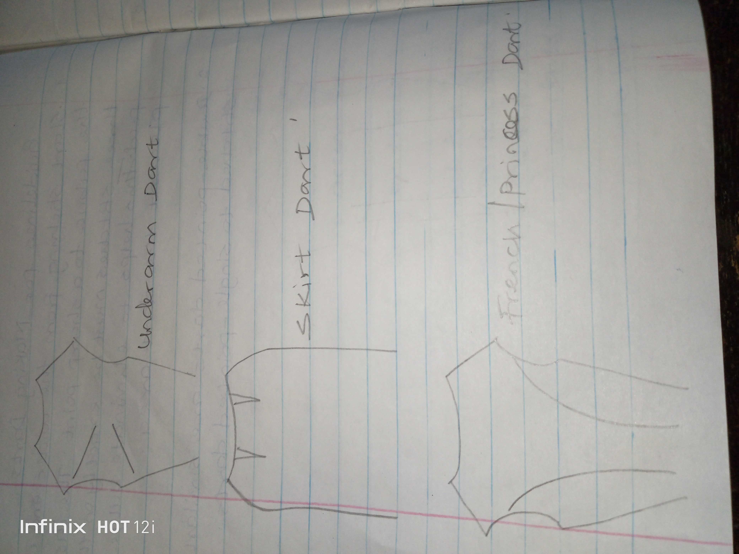
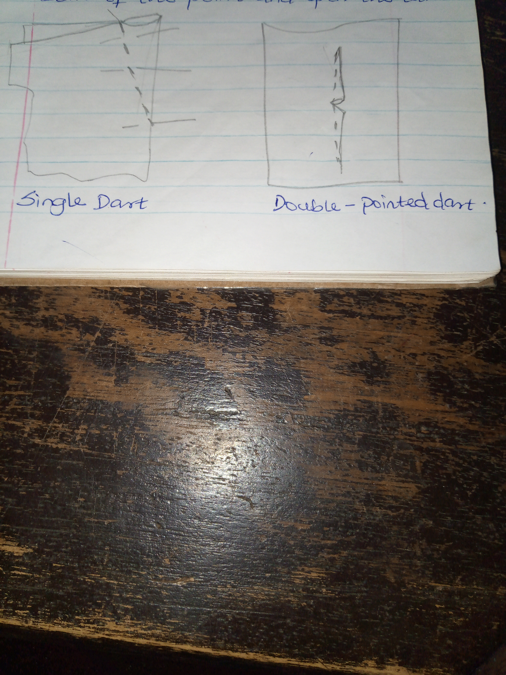
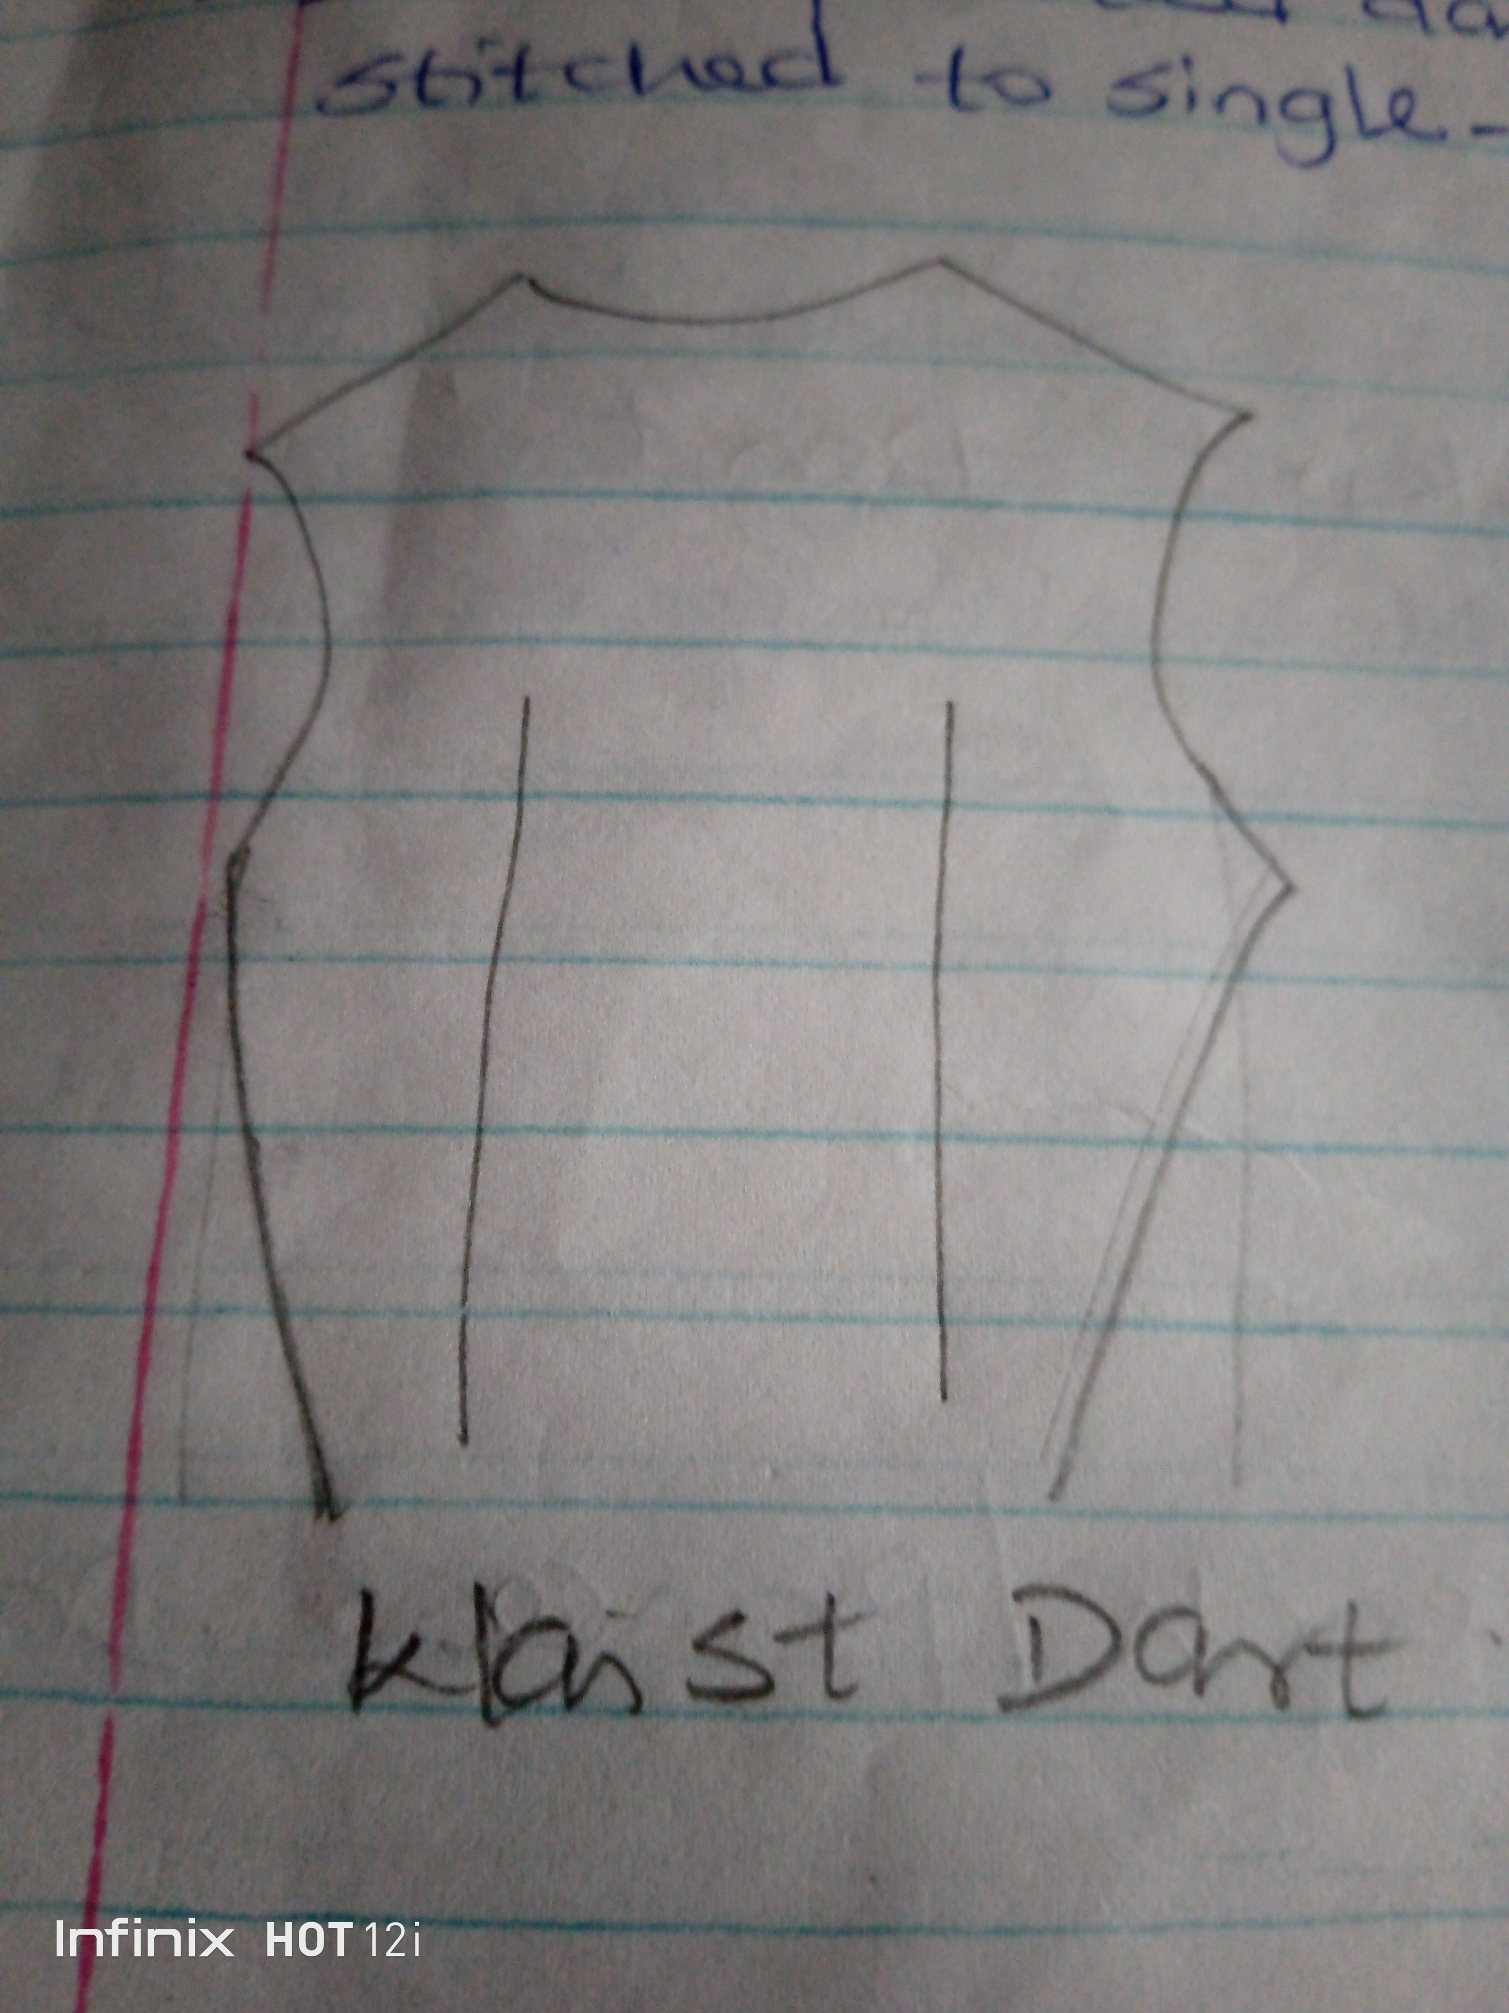
7. Skirt darts: To accommodate hip shaping.
Guidelines for making Darts
1. Start stitching from the wider end of the fabric to a sharp point. The last three stitches must be exactly on the fold. This helps to eliminate bulge or pleats in the dart area.
2. Double-pointed darts are similarly stitched to single-pointed darts.
How to make a Dart
i. Fold the material so that the right-side face and the pattern lines of the darts are together.
ii. Pin and tack the dart on the pattern line
iii. Stitch from the broad and towards the point bringing the stitching right off the fold. Sew off or knot the ends of the thread.
iv. Press the dart to one side of the stitching or cut along fold to within 2cm of the point and open the turn.
Reasons/Importance of Dart
1. To control fullness
2. To decorate garment
3. To accommodate figure curves
4. To create firm look especially the skirt
5. It helps fabric the fit the shape of the woman body
6. It gives good fitting and shape to the finished garment.

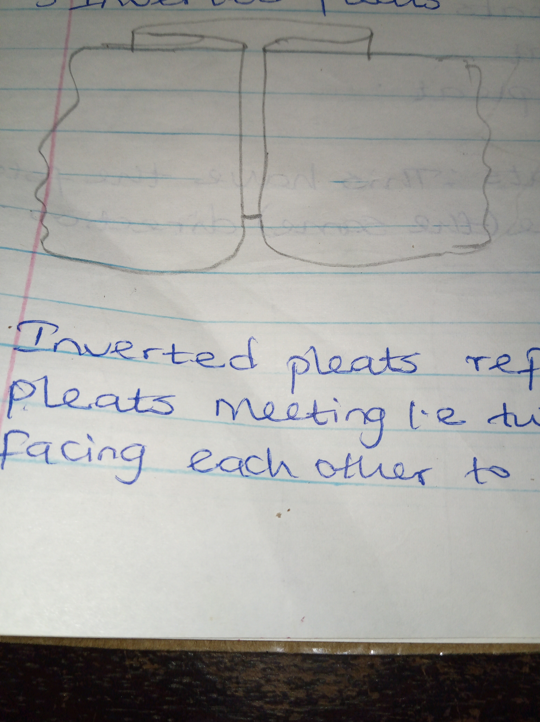
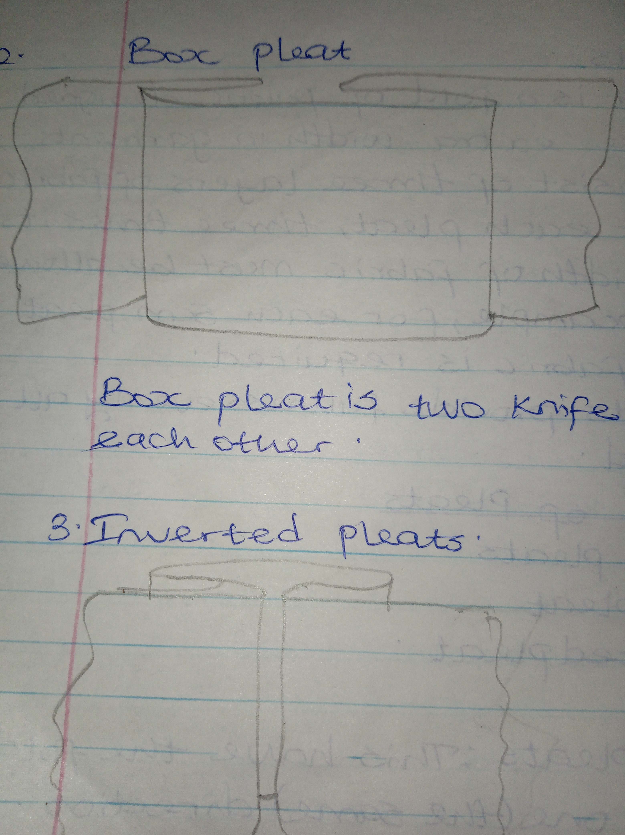
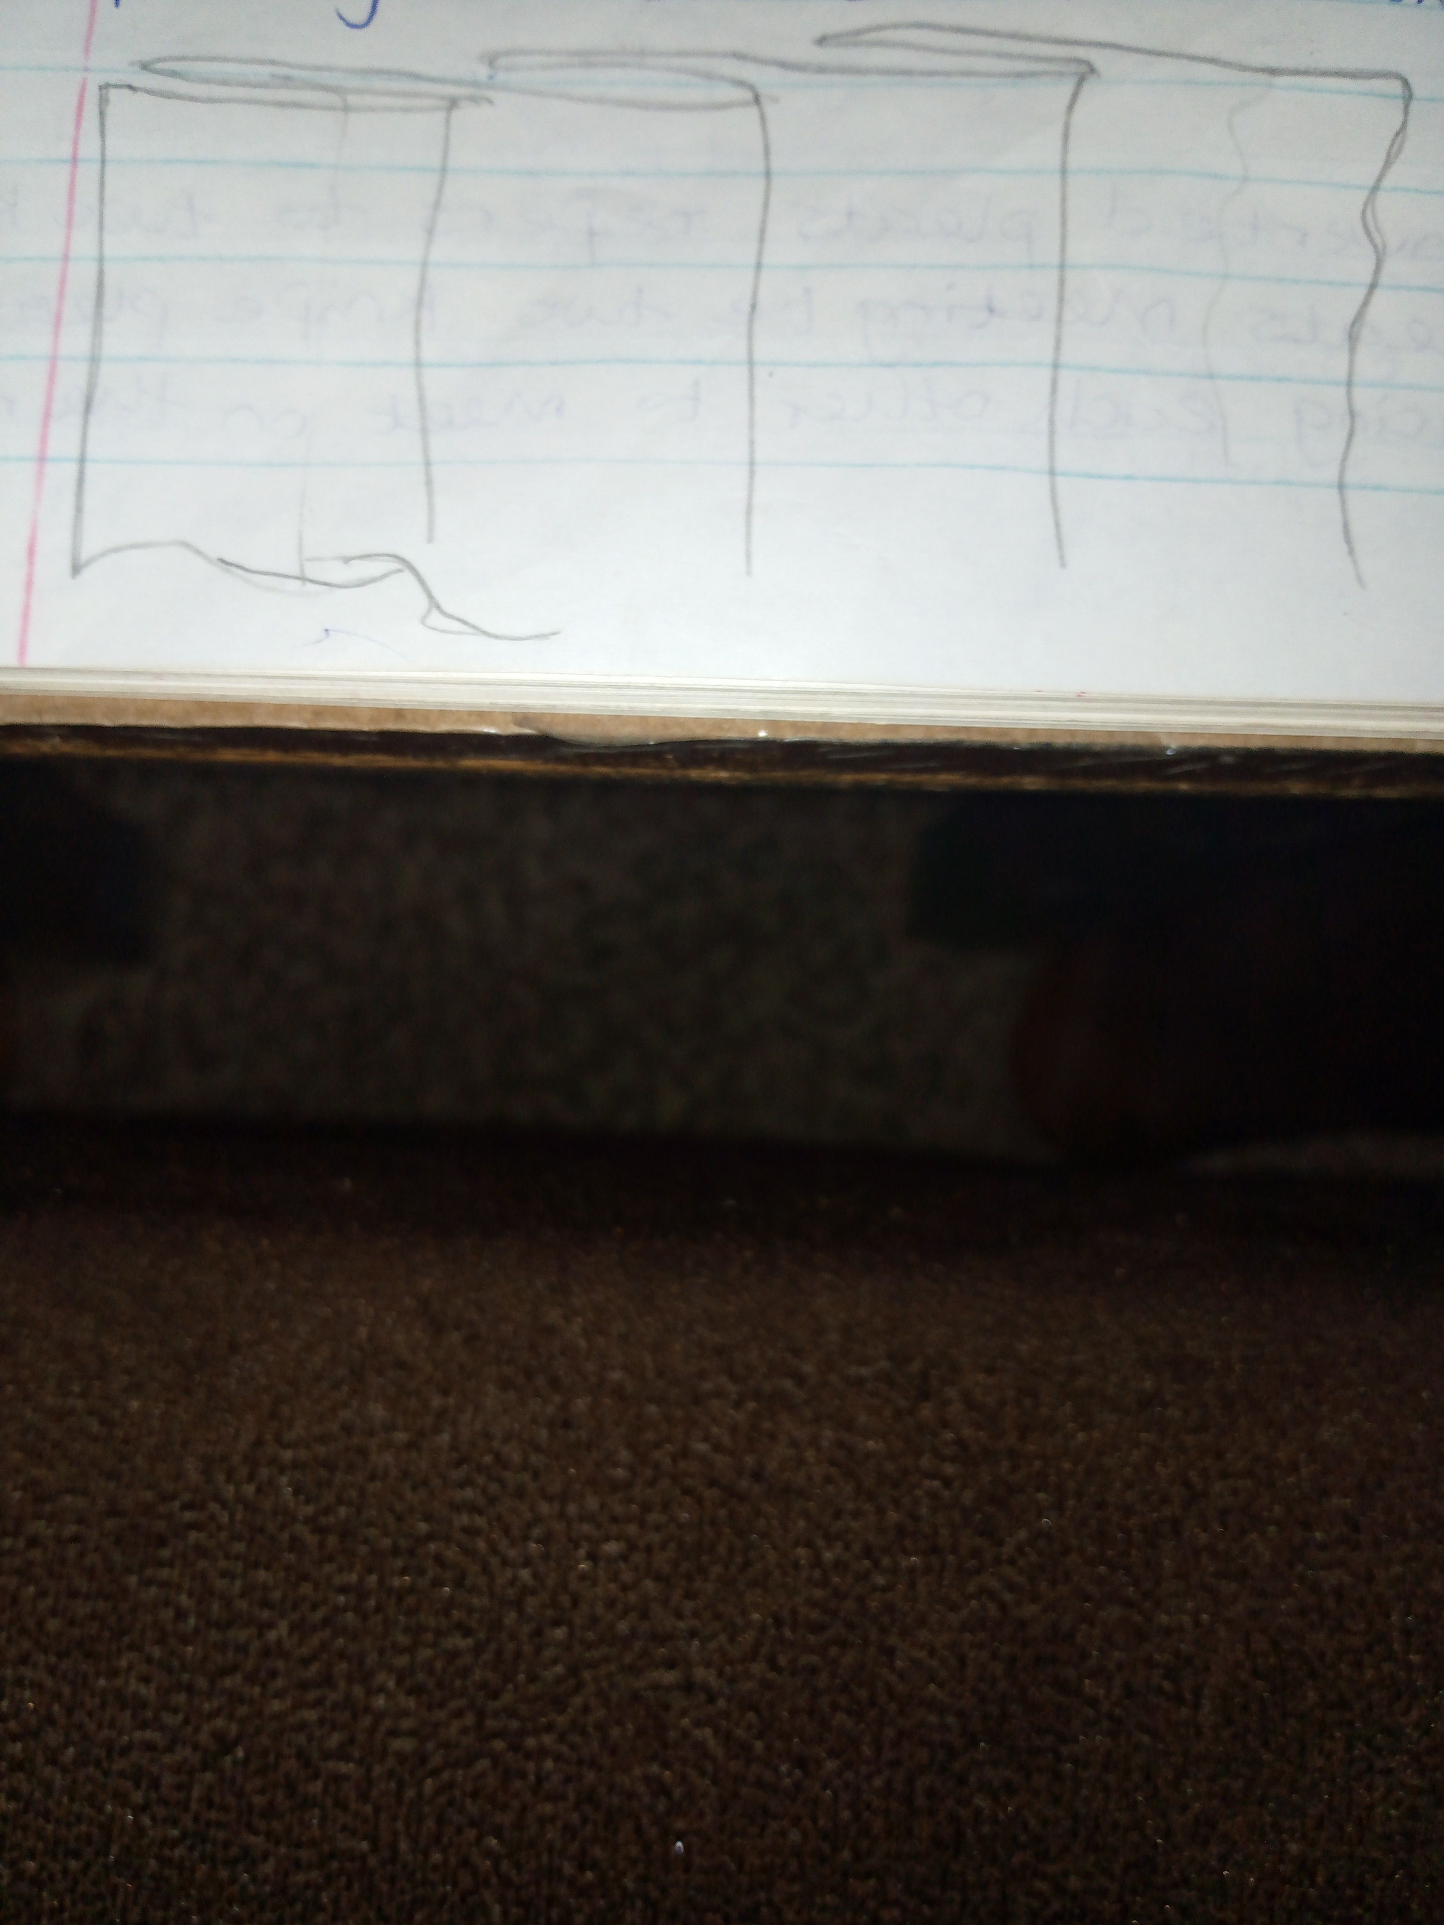
2. PLEATS
A pleat is a fold of fabric designed to give extra width in garments. It consists of three layers of fabrics, so for each pleat, three times its own width of fabric must be allowed. For example, for each 5cm pleat 15cm fabric is required. Pleats provide fullness evenly all around.
Kinds of pleats
1. Knife pleats
2. Box pleat
3. Inverted pleat

1. Knife pleats: This have the folds facing one (the same) direction.
2. Box pleats: Box pleat is two knife pleats backing each other.
3. Inverted pleats: Inverted pleats refer to two knife pleats meeting i.e. two knife pleats facing each other to meet on the right side. It is otherwise called kissing pleats.
Reason for Pleats
1. It provides fullness
2. It is used to decorate clothes
3. They serve as style feature
3. TUCKS
Tucks are folds of fabrics lying parallel or horizontal to each other. They can be used for shaping garments for adults and children, usually on the right side of garment.
Uses of Tucks
a. For decoration
b. They dispose (get rid of) fullness and introduce shaping e.g. Tucks at the shoulders of a bodice
c. They serve as style feature
d. It adds bodices to thin fabrics
e. It adds design to plain fabrics
f. It can be used to hide joining in fabric
g. It provides extra width in garment.
How to make Tucks
1. Fold the material with the wrong side facing
2. Make small running stitch to fix the tuck at an even distance
3. Work the stitches with the side upper most which will show when the tucks are pressed
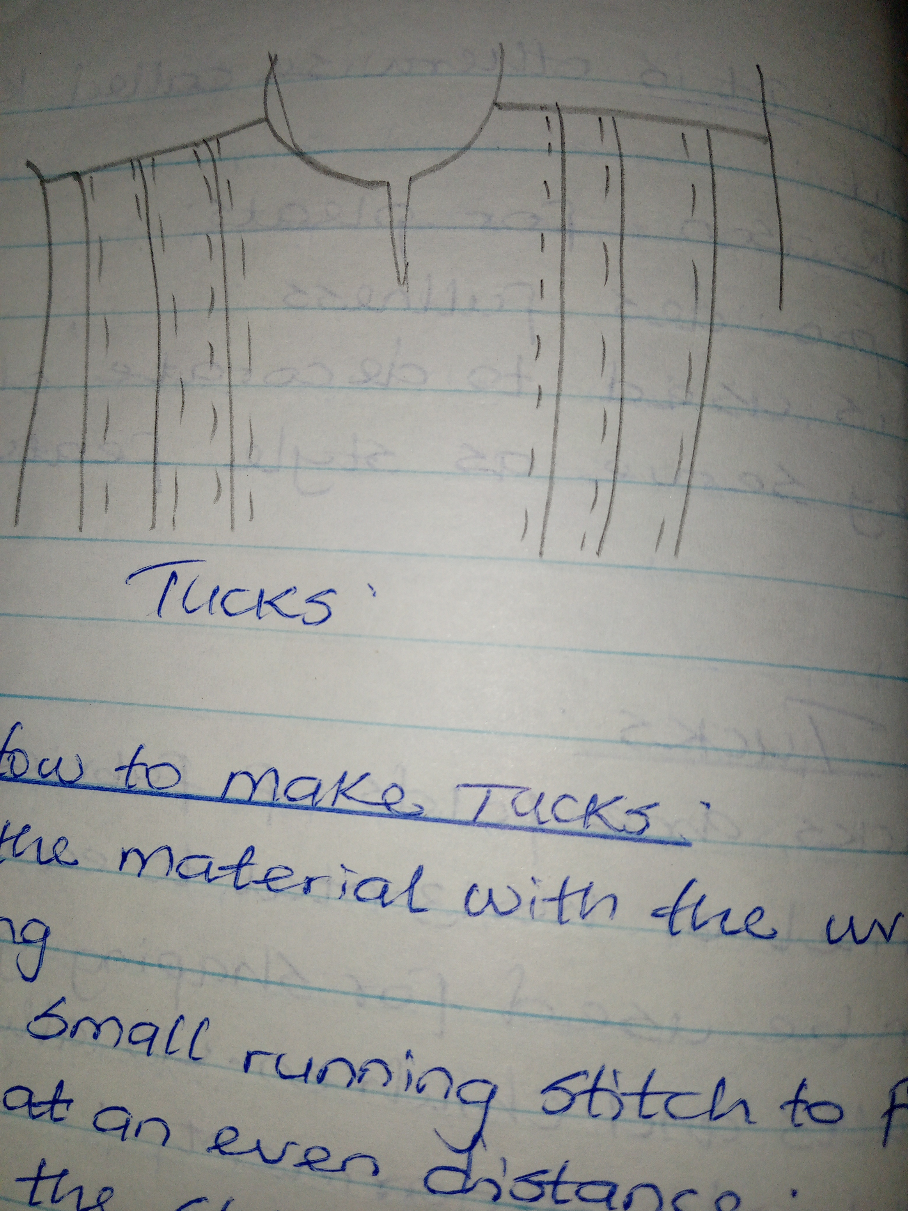
4. When all tucks are stitched, press them in position.

4. GATHERS
Gathers are soft folds of fabrics formed by the fabric fit into a pre-determined area.
Positions of Gathers
i. Around waist
ii. Yoke lines
iii. Waistlines
iv. Neck lines
v. Upper and lower edges of sleeves.
If light weight fabric is used, allow approximately twice the width for gathering and if heavy weight fabric is used, allow approximately one and half times the width for the gathering as is required for the finished width.
How to work gathers
1. By hand
2. By machine
1. By Hand:
- Use running stitch. Allow up to twice the width of material the ring as required for finished width.
- Thread the needle and hold the fabric in place
- Work two rows of running stitches, one on the pattern line and the other 6mm away in the turning
- Pull up thread together and wind the thread to the required width
- Pull gathers until they are evenly distributed
- Fasten off each thread with a back stitch.
2. By Machine:
- Thread the machine in the usual way
- Adjust the stitch to its longest length
- Work two rows of machine stitches
- Fasten off beginning of each thread
- Draw up under-thread of both rows of gathering together and fasten off both threads.
Uses of gathers
1. It's a style feature
2. It provides fullness
3. It decorates garment
5. FRILLS/RUFFLES
This is a fabric strip cut and handled in a way as to produce fullness.
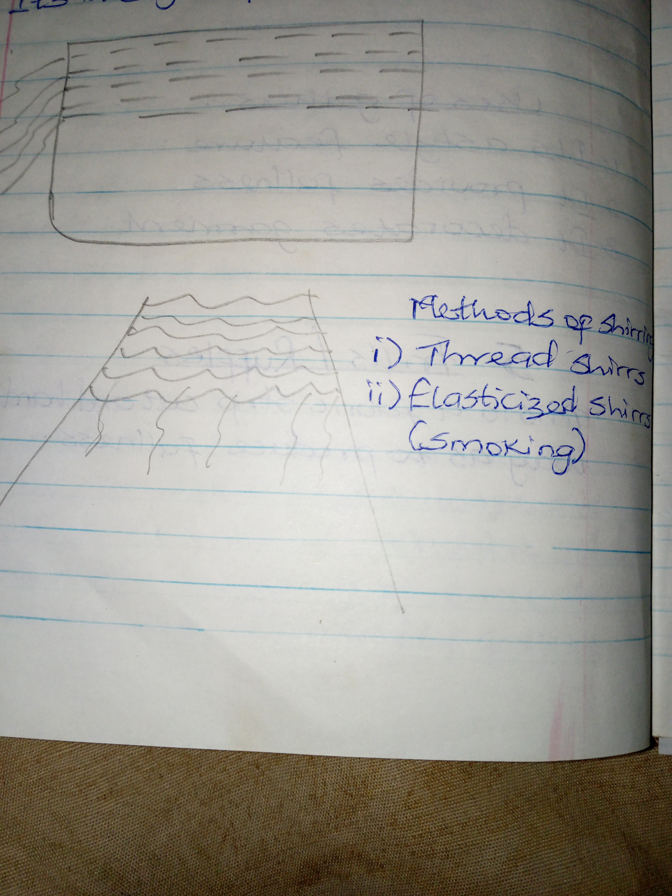
6. SHIRRING/SMOCKING
Shirring is made with several rows of gathering that are reinforced.
Reasons for Shirring
1. To beautify garment
2. It controls fullness decoratively
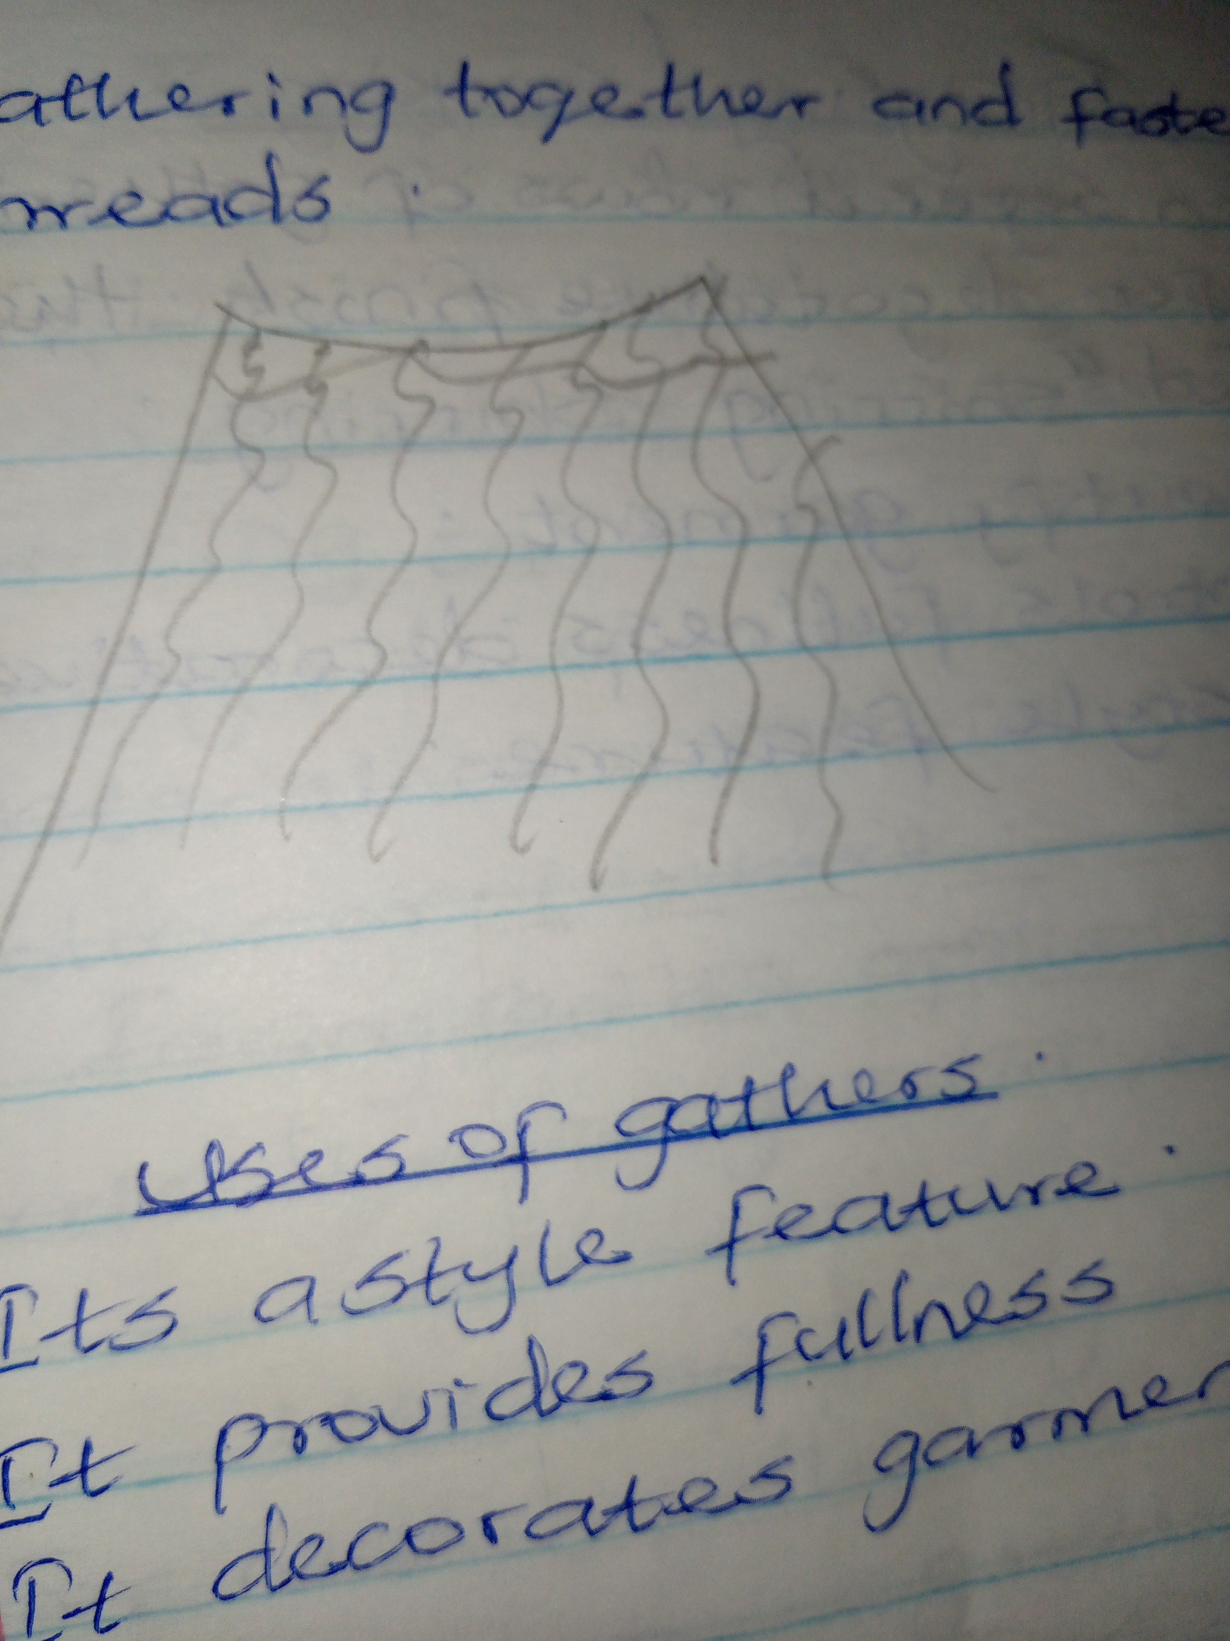
3. It's a style feature

