SUBJECT**:** Garment Making

CLASS: SS1

INSTRUCTIONS: Print and Spiral bind

**SCHEME OF WORK**

1. Introduction to Garment making

2. Concept of garment designing

3. Elements of designing

4. Principles of design

5. Figure types

6. Entrepreneurship in garment making

**INTRODUCTION TO GARMENT MAKING**

**Meaning of Clothes/Garment**

Clothes are articles we put on the body to protect, beautify or adorn it.

**Reasons for wearing clothes**

1. Protection: Clothes are worn to protect the body from different weather conditions e.g. rain, rough harmattan weather and from harmful things such as insects.

2. Appearance: Clothes are used to beautify the self and improve appearance.

3. Modesty: Clothes are worn to cover our nakedness and make us appear decent.

4. Mood: Clothes help to show our mood or feelings.

5. Role identity: Clothes show the roles which people perform or their duties.

6. Status or Position: Clothes help to show the status or positions which people occupy in the society. e.g. traditional rulers.

7. Culture: Clothes help to show the culture of a group of people e.g. "Buba and Iro" which are commonly worn by the Yoruba women.

**Clothes for different occasions**

1. Clothes for Formal Occasions: Formal Occasions include interviews, meeting, and workshops. Such occasions require smart, neat and simple clothes worn with matching accessories.

2. School clothes: These should be simple and comfortable. They should be washable fabrics such as cotton.

3. Sport Wears: These should allow for freedom for body movement. They should be sewn to cover the body decently.

4. Clothes for Household work or activities: These are casual clothes worn during the day. They should be comfortable and of simple style. They should be made of washable and durable fabrics.

5. Under Wears: These are worn directly against the skin. They must be easily washable fabrics that are also absorbent e.g. cotton

6. Work Clothes: Some jobs require uniform e.g. nursing. Work Clothes should be chosen to suit the kind of work. Shoes should be low-heeled and comfortable.

7. Night wears: These are for bedroom use. Outside the bedroom, a dressing gown should be worn over the night dress. Night wears should not be tight but loose.

8. Season Wears: People who live in the country that have four seasons, wear different clothes for each season. The clothes that they wear in spring, in summer, in autumn or fall are different from in winter and vice-versa.

**Clothing Items**

Clothing items include dresses, shoes, sweaters, laboratory coats, jewelry, umbrellas, handbags, hair accessories, hats, night gowns, suits, trousers, scarfs, ties etc.

**THE CONCEPT OF GARMENT DESIGNING**

Fashion designing is art of the application of design and aesthetics or natural beauty to clothing and accessories.

**Who is a Fashion Designer?**

A fashion designer is an individual who designs clothing. Fashion designers work with all types of clothes, from children's wear to individual safety gear and everything in between. They even design accessories, such as handbags and hats.

This profession is not as simple as whipping up a pretty drawing or sewing a single top. Designing clothing is a complicated job that entails deliberating over function cost, aesthetics, style, and more.

This broad description doesn't do justice in conveying the wide range of tasks and responsibilities that fall under this profession. Below is a list of career options that fall under the umbrella of fashion design to help you understand the breadth of opportunities in this field.

* Design Assistant
* Fashion Designer
* Textile designer
* Dress Maker
* Stylist
* Technical designer
* Pattern maker or cutter
* Tailor or seamstress
* Fashion buyer
* Illustrator
* Fashion Forecaster
* Production Manager
* Manufacturing coordinator
* Sample sewer
* Couturier
* Costume Designer

**What is a typical fashion designers job description?**

A typical fashion designer's job description can include:

* Conceiving ideas for collections and individual garments
* Researching and forecasting industry trends
* Sketching designs for various types for apparel and accessories
* Developing story boards and inspiration boards
* Collaborating with design, teams to create garments and lines
* Selecting fabrics patterns, colours, silhouettes, trims and embellishments.
* Presenting design ideas for approval or sale
* Designing textiles for use in garment
* Drafting patterns using computer application and manual techniques
* Manipulating and grading patterns
* Creating technical design in illustrations (Flat)
* Constructing sample garments

Fashion Designer works in a particular niche. The most popular specializations include:

* Children's wear
* Intimate apparel
* Knit wear
* Bridal/Special occasion wear
* Women's day wear
* Native wear
* Accessories.

**ELEMENTS OF DESIGN**

Designing refers to the transformation of ideas, perception or concepts into concrete plans (picture form). It makes it possible for what is imaginary and what is in the mind of a person to be made concrete for everybody to see and have access to.

**Importance of Designing**

1. It guides a clothing producer to produce exactly what is desired.

2. It helps to hide figure faults and highlight nice features.

3. It reflects the ideas, skills, and interest of the designer

4. It reflects our values and self image

5. It makes it possible for ideas to be transformed into picture form.

6. It provides a preview of the intended or expected product.

**Identification of Elements of Design**

Elements of design include:

1. Colour

2. Line

3. Dots

4. Form or shape

5. Texture

6. Space.

All these contributes to the overall design of a garment or an article.

1. COLOUR: This refers to the appearance that something has as a result of the way in which it reflects light. It's the most existing design element that catches the eyes first.

**Importance of Colour**

1. It enables us to express ourselves and affect how we feel

2. It makes clothes seem warm or cool

3. It can create several impressions to make us look taller, shorter, larger, smaller, happier or sad, i.e. It reflects mood.

4. It enhance cloth selection.

**Selecting Colour Design**

1. A dark colour reduces figure size while light colour increases figure size.

2. Warm colours are more prominent than cool colours

3. A colour in print is highlighted to draw it out

4. Harmonious colours adjacent on the colour wheel can soften each other

5. Colours can be used to emphasize proportion in the garment

6. Contrasting colours intensify each other i.e. makes figure shorter

7. The intensity of colours can be subdued by the addition of tint

8. Colour can accent deferring features such as pockets, collars, cuffs

9. Colours can be used to highlight your best features such as your eyes, hair or skintone.

**Expressions of Colour**

**1. Red:**

Excitement, power, danger, aggression, anger, passion, love, energy.

2. **Yellow**

Cheerful, bright, sympathy, cowardice, wisdom, warmth

3. **Blue**

Calm, serious, reserved, depression, dignified, serenity

4. **Orange**

Lively, cheerful, friendly, energy, warmth

5. **Green**

Refreshing, restful, peaceful, luck, envy, hope

6. **Purple**

Dignified, dominating, mysterious

7. **White**

Innocence, purity, faith, peace

8. **Black**

Sophisticated, despair, death, mourning, wisdom.

**Types of Colour**

1. Primary colours

2. Secondary colours

3. Tertiary colours

1. **Primary Colours:** These are natural colours which are Red, Blue and Yellow.

2. **Secondary Colours:** This is obtained by mixing two primary colours together in equal proportion.

I. Orange= Yellow + Red

II. Green= Blue + Yellow

III. Purple or Violet= Blue + Red

3. **Tertiary colours:** They are six in number and they are;

I. Red-Orange

II. Yellow-Orange

III. Red-Violet

IV. Yellow-Green

V. Blue-Green

VI. Blue-Violet

Other classifications of colours are;

1. Warm Colours: Warm colours are bright, sharp and attractive. They are; Red, Yellow, Orange, Yellow-Orange etc.

2. Cool Colours: These are bright but not sharp colours e.g. Blue-Green, Blue, Blue-purple etc.

**Colour Schemes**

These refers to the combination of two or more colours to produce an harmonious outfit.

1. Monochronic Colour Scheme: This uses different shades of the same colour or one colour with white and black.

2. Contrasting Colour Scheme: This uses two or more different colours in varying strengths e.g. Blue and Red.

3. Toning Colour Scheme: This uses two or more similar colours e.g. purple and blue.

**Points to remember when choosing colours**

1. Cool colours make one look smaller

2. Warm colours make one look larger

3. White goes with all colours

4. Brown goes well with Yellow, green, light blue, Orange etc.

5. Grey is a neutral colour that harmonizes with red, yellow, blue, green, orange and purple

6. Black goes with all colours except dark brown because there will be no contrast.

**Guidelines for choosing colours in Clothes**

1. Choose colours that suit your personal complexion and size.

2. Choose that which fits other colours in your wardrobe

3. Dark complexion should choose bright colours

4. A plump or bulky figure looks slim in dark colours

5. Slim figures look Fuller in light bright colours

6. Light and colours emphasize figure faults

7. Short plump figure should avoid contrasting blouse and skirt in opposing colours. Makes them look shorter.

**Special terms used to describe Colour**

1. Hue: This is a specific colour name e.g. Red, Green.

2. Value: This is the lightness or darkness of a colour

3. Shade: This is the darker value, obtained by adding black to a colour

4. Tint: This is a lighter value, obtained by adding white to a colour

5. Intensity: This is the brightness or dullness of a colour

6. Colour Wheel: This is an arrangement of colours in a circle like the face of a round clock, to show how they are related.

2. **Line:** Line refers to a long narrow mark traced on a surface. Lines have directions of width and length. All lines in design are either straight or curved.

**Importance/Reasons for Lines**

1. They connect parts of articles or garments
2. They emphasize or create height, conceal weight or focus attention to certain area.
3. It draws attention to a person's best feature and hide the less attractive ones
4. It gives a slimming effect
5. It outlines and forms outer and inner spaces of garments and other articles

Lines in garment can be:

* + - 1. **Structural**: These are lines formed by the use of seams, darts, panels or princess lines. They are the assembly details which also create visual interest. Examples are; princess line, hip yoke, and high waistlines. They add beauty to a garment.
      2. **Decorative:** These are parts of fabric design or trimmings added to garments. Rows of buttons and top stitching also create decorative lines.

**Types of Line**

There are four types of Line which are;

**1. Vertical lines:** These can add height i.e. it creates an impression of extended height which makes a figure look slender. Vertical lines are lines that goes up and down.

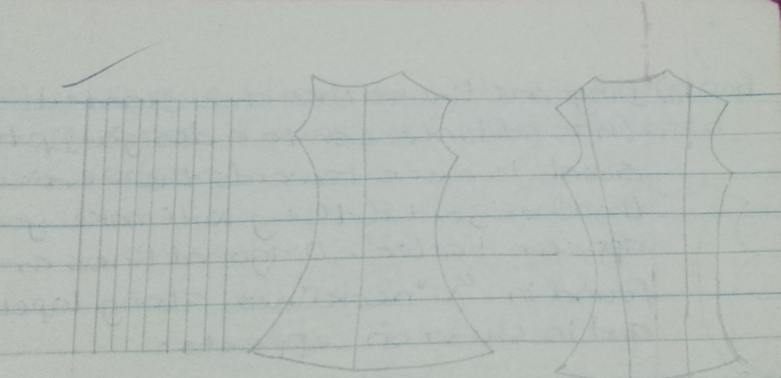

2. **Horizontal lines:** These are lines which run across the fabric or article and carry the eye across from side to side to make you look shorter, wider or fatter. A wide belt creates a horizontal line to make a person look shorter or fatter.

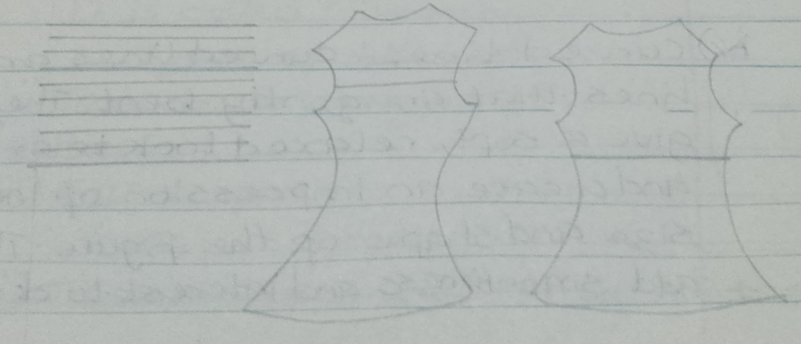

3. **Diagonal lines:** These are slanted lines that add interest to a design. If the slant is more towards the vertical than horizontal, they will make you appear taller. Diagonal lines are found in "V' neck lines, along lapels and in Chevron effects.

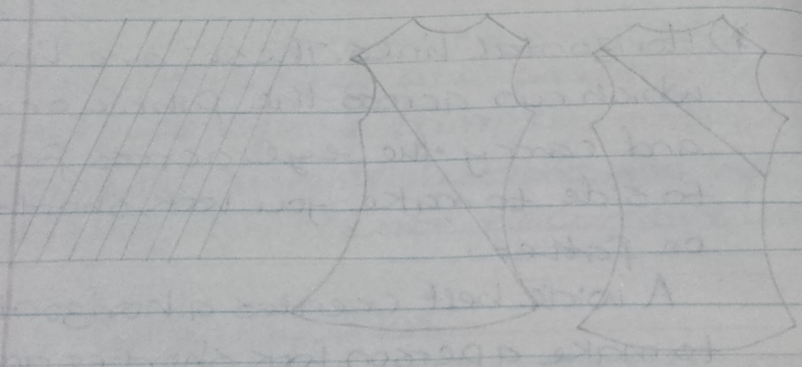

4. **Curved lines:** Curved lines are lines that are gently bent. They give a soft, relaxed look to articles and create an impression of increased size and shape of the figure. They add smoothness and interest to designs. Curved lines are found in round and scooped necklines, along scalloped edges.

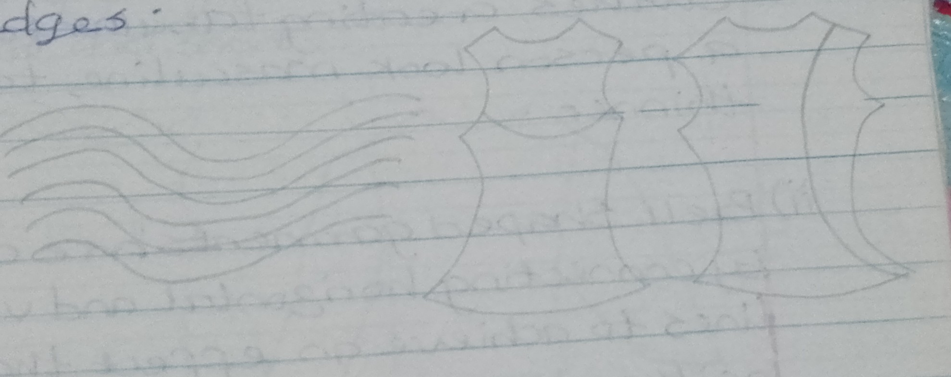

3. **Shape or Form(Silhouette)**

A shape is an enclosed area. It is created by the cut and construction of the garment. It refers to the outline of an outfit when seen from a distance or in a shadow. It is called Silhouette.

**Types of Silhouette**

I. Tabular or boxy shape

II. Bell

III. Full shapes.

I. Tabular shapes have narrow skirts, for example tight fitting dresses, straight or slim sheath dress and suits. Clothes creating tabular form makes a person look masculine, taller and thinner.

II. Bell shaped garments are created by connecting horizontal and vertical lines to achieve an effect that is neither horizontal nor vertical. Bell shaped garments have wider skirts and are flattering to most people. They conceal curves thereby hiding figure faults. Examples are flarred skirts, "A" line garments and capes.

III. Full shapes are dominated by curved lines. Full sleeves, skirts or dresses that are gathered are examples of full-shaped garments. They tend to widen the figure and reduce height. Slim and tall persons can choose full shaped garments to make them look fat and short.

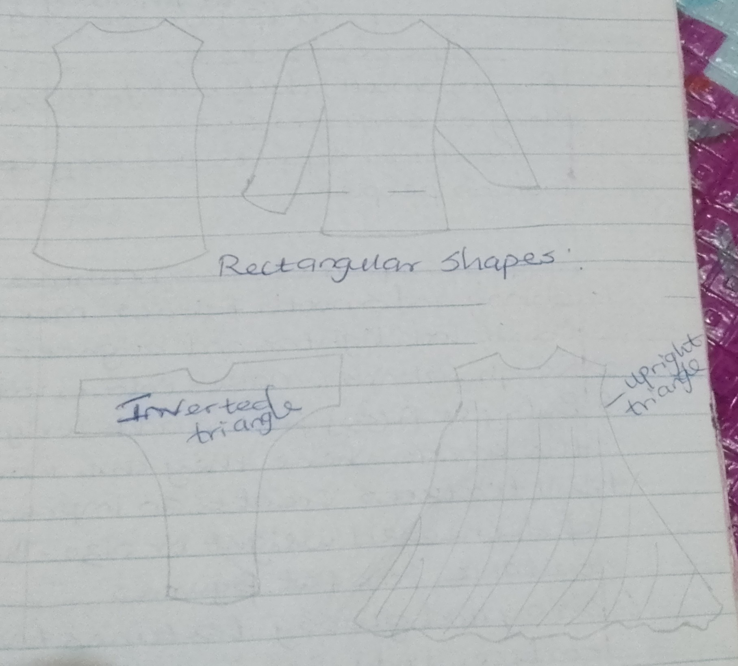

4. **Texture**

Texture refers to how the fabric surface feels and looks. It describes fabric quality. It is the main body of an article irrespective of the design.

**Types of texture**

Rough, smooth, dull, bulky, fuzzy, soft, shiny or sniff texture. Texture affects the way colours look on people.

**Effects of Texture on Fabrics**

1. Shiny and smooth fabrics makes colour look lighter and brighter

2. Rough fabrics makes colours look dull

3. Bulky or fuzzy fabrics add weight to the areas where they are worn

4. Dull textures create an impression of decreased weight or size. Therefore, suitable for fat figures.

5. Shiny and glossy textures tend to reduce body size.

5. **Dots**: A dot is a simple spot of colour in image formation. A line results from a connection of series of dots. Dots are made in sizes. Large dots on a fabric pattern tend to make the wearer look fatter, while smaller dots can make the wearer appear slimmer or smaller. Examples are, Round patched pockets, applique and prints.

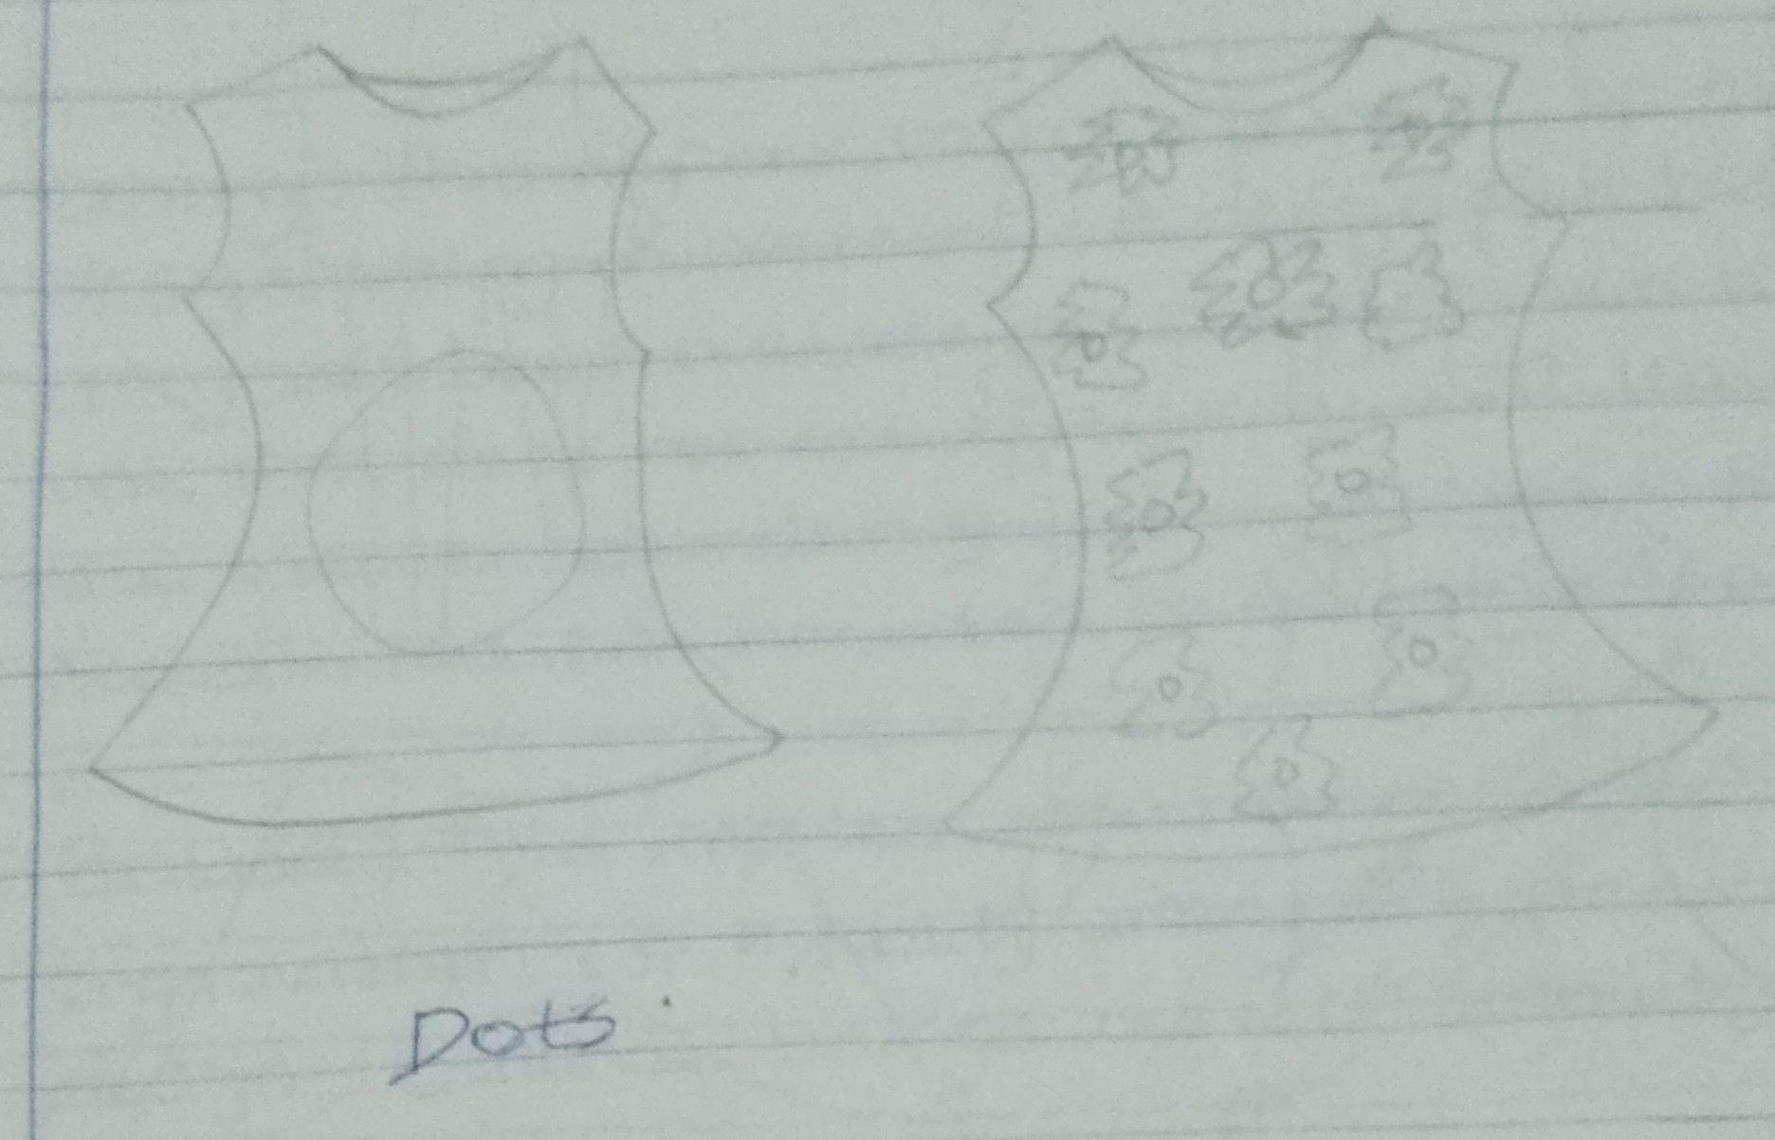

6. **Space:** Space is the entire area in a garment. Poor spacing of any are arrangement spoils its beauty. Equal divisions of space can be monotonous while uneven distribution of space becomes more interesting.

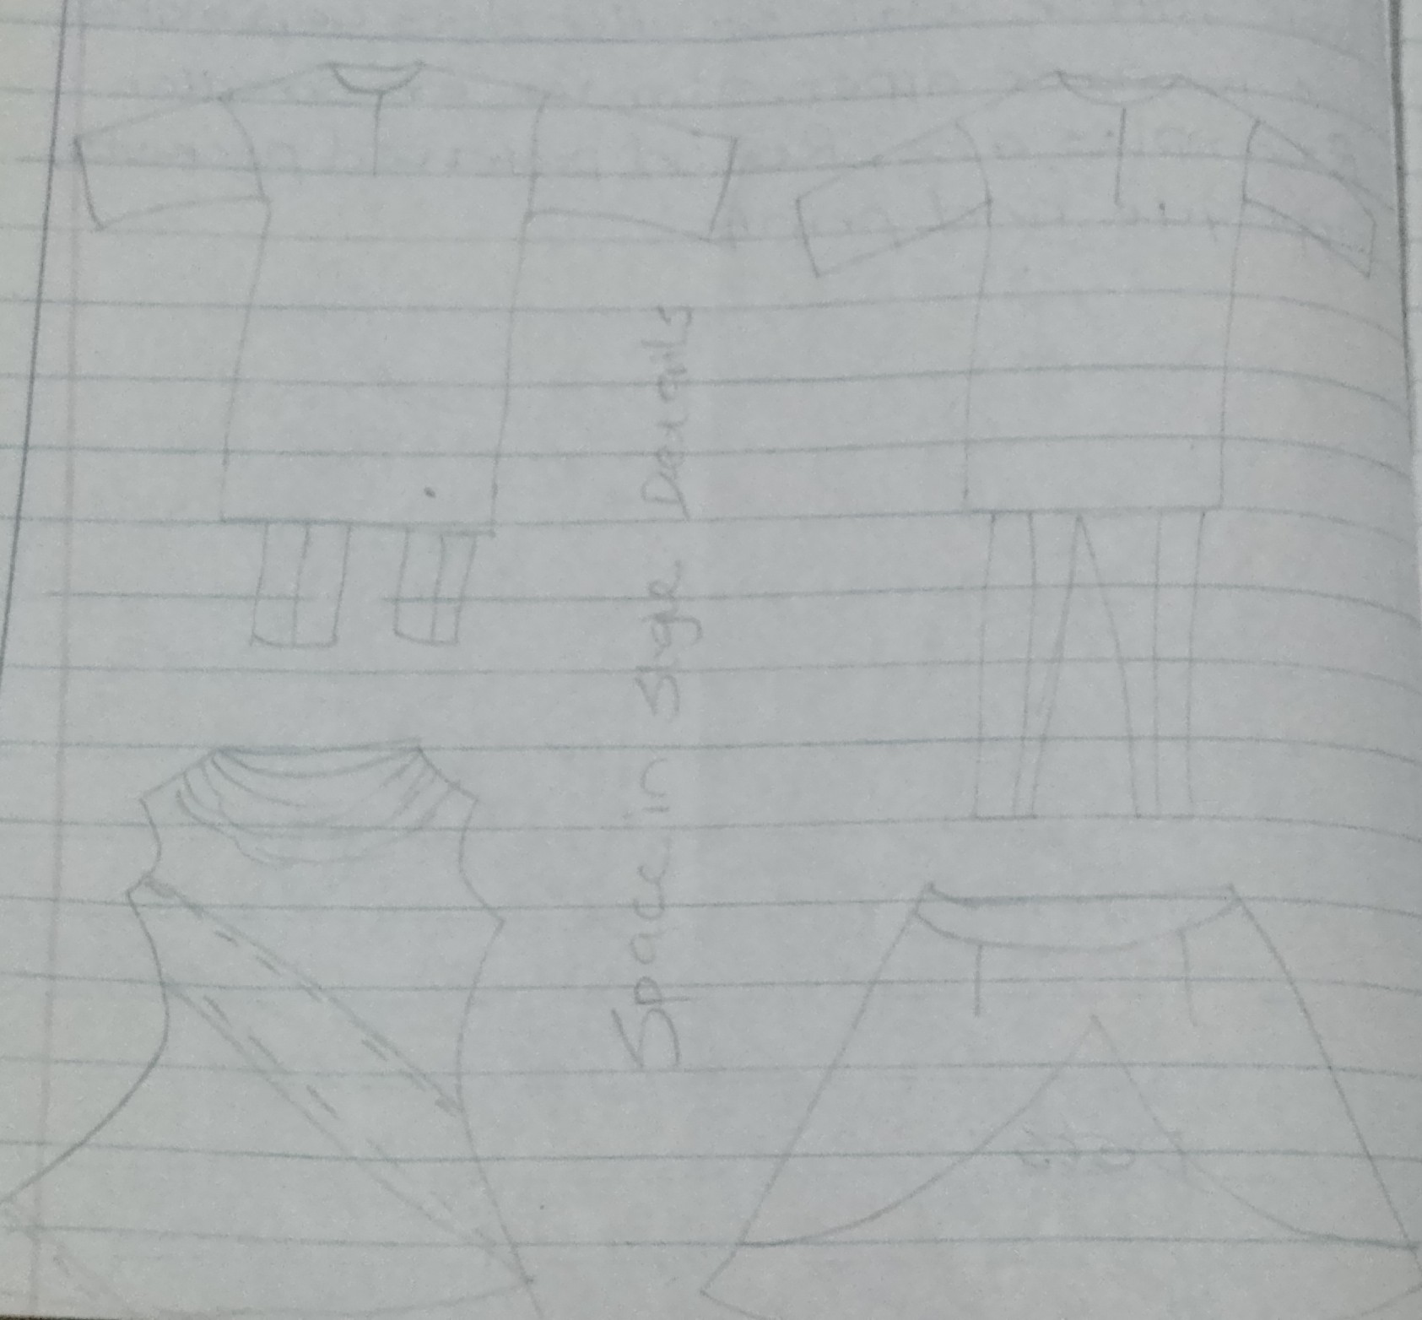

**PRINCIPLES OF DESIGN**

This refers to the rules which guide the organisation of the elements into a design. They are the guidelines(methods) used in combining the elements to produce a design that is unique and attractive. The principles are;

* Emphasis
* Unity or harmony
* Rhythm
* Balance
* Proportion
* **Unity**: This refers to all elements of the design being in harmony. A design that has unity will have a sense of completeness while one that does not achieve unity will leave the viewer wondering if the design is finished. Accessories can be used to add unity to a design.
* **Balance:** This implies equilibrium in design organisation i.e. equality among the parts of design. Balance brings overall stability to design. It is achieved in a design when different parts of a design draw equal attention to onlookers.
* **Proportion:** This refers to the size of one part of a design in relationship to the rest. Proportion is determined by how the total space is divided not in terms of being equal but when all the parts work well together, the garment or article is well proportioned rather than out of proportion. For instance, proportion in a suit would be the length of the jacket in relation to the length of the trouser or skirt. Clothing should also be in proportion to a person's size.
* **Emphasis:**  Emphasis is the centre of interest of an outfit. It refers to the part of the design to which the eye is instantly drawn. Without the centre of interest (emphasis) an outfit looks unplanned and monotonous. It is best to have one main area of emphasis.
* **Rhythm:** This refers to the using of items repeated. It can be repeating the same shape, lines, space, colour in all of the designs.
* **Harmony:** This means a pleasing visual unity. It is created when elements of design are used effectively according to the design principles. Harmony gives the feeling that all the parts of an outfit belong together and suit the wearer and the occasion.